Power Transformers
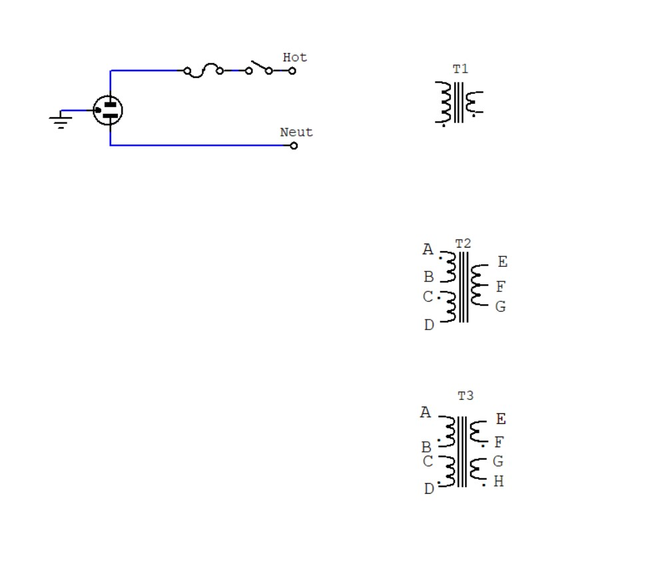
What are the little dots on windings?_____________________________________________
What is the winding being energized called?_______________________________________
Assume each large winding is 120V, and each small area 10Vac.
Assuming we want 240Vac, what connects to what?_________________________________
Assuming we want 120Vac, what connects to what?__________________________________
What is T2-F called?_______________________________________________
For next week, assuming 10Vac on each small winding, how many output voltages and types can we make out of T3??

